Olympos Natural Living Village

Project Summary
50 bed capacity 4 * ecologic hotel, outdoor sports, yoga, wellness, healthy living workshop organization, local healthy natural food, vegetable and fruit juices prepared restaurant
Sport holiday is rising trend in the world.Sport and healthy living lovers prefer small quiet hotels in nature. Olympos and the surrounding area is perfect location for outdoor sports .
Our goal is great and offers comfortable accommodation in nature, healthy and delicious regional food and nature sports is to provide European and Turkish guests service.

Objective

We built 13 log houses .These houses have comforts of spacious rooms,high ceiling and large bathrooms.
We offer healthy local dishes from Mediterranean cuisine menu in our restaurant and dishes will be prepared with products from farms around us and our garden.
Extreme sports **, yoga sessions and wellness education rising trend in the tourism industry with a sports and Wellness vacation programs, we aim to provide.
** Sea kayaking and walking the Lycian way, mountain bike tours, canyoning, horse riding and scuba diving
.

The Target Groups
To get away from the stress of city life crowd and calm in nature, personalized holiday who prefer 25-55 years, domestic and foreign corporate company employees, nature and outdoor sport lovers, dietician, and under the control of the weight and healthy nutrition, aimed at domestic and foreign guests, cultural tourism and viewing the ancient era. Turkey and the European yoga clubs

The Region's Structure
Olympos
3250-metre long beach University of Wales was founded in 2003 by the beauty of nature and in terms of the world's most beautiful beach.
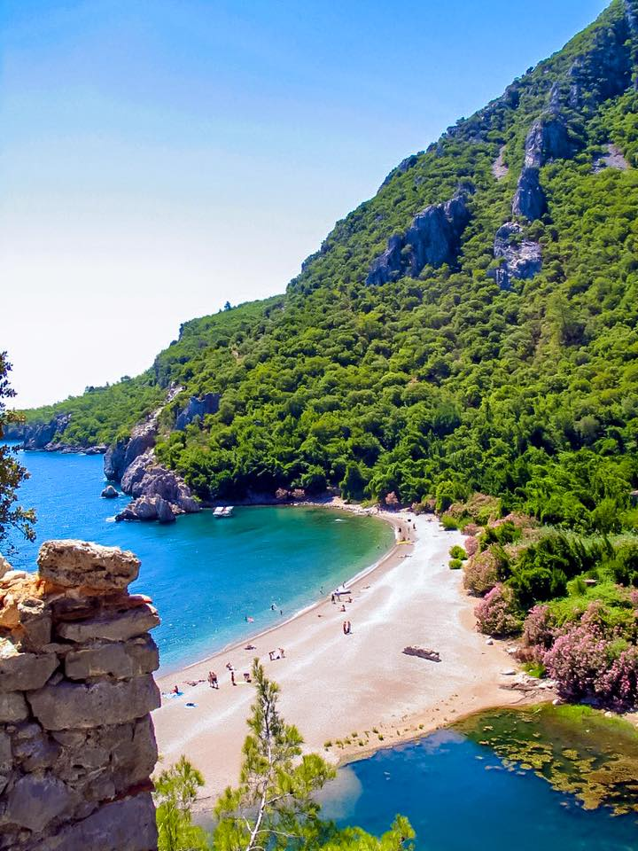
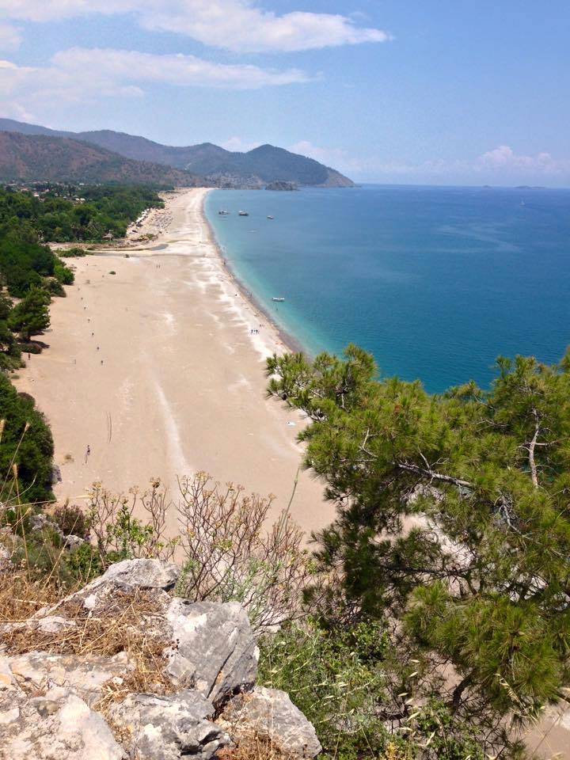
One of the world's 10 most beautiful ancient hiking trails on the Lycian way,
The ancient city of Olympos national park, including in
Year 12 million tourists came from 75 km west of Antalya, tourism planning and 2016 in the targeted area end
A neighboring village and 7 km from the beach by car from Çıralı 3.5 km away
Other natural wonder Adrasan Bay 1 km
20 km from the ancient city of Phaselis

We built

Restaurant-Juice Bar
150 m2 internal 100 m2 outdoor space-driven stone buildings, a fully equipped kitchen and restaurant in
3 rooms (40 m2 .30 m2, 25 m 2) 1 small room (6 m2)

110 m2 swimming pool and sitting in sections

100 m2 sized staff rooms

8 log house ; the size of 37 m2 , 1 bedroom, 1 bath , 1 loft
5 log house ; the size of 55 m2, 2 bedrooms, 1 bathroom, 1 loft
All houses are fully furnished .
Garden landscaping fruit, olive trees

Things to do

- Two pieces 3 room 1 saloon 80 m2 log house ordering and installing
2) 1 x 120 m2 size social activity wood building ordering and installation. We are going to use it for company meetings , wellness seminars, yoga meditation sessions

- Health Club with sauna and Turkish bath
- 30 KWA Ghosh energy electric system installation new houses in-room furnishings and decoration materials supply
- kitchen conveyor oven, vegetable and fruit juice mixer garden irrigation
- 100 ton water tank construction
- Garden irrigation system

Sales support tools

17-metre wooden boat
Airport Shuttle Van

Promotional Advertising Activities

comprehensive web site related publications promotion,
foreign participation in the exhibition related to breaks, adventure, sports
domestic tourism fair participation,
Domestic and international corporate companies travel sections,
interested in Club, yoga University brochures with promotion,
Douglasville and domestic travel agents brochure with introduction and agreement,
online travel agency of promotion and deal.
Billboardlarda presentation, newspaper and magazine writers,
with commercials, to be prepared by the social media and web site promotion,
those who love nature sports via blog promotion and advertising,

www.olymposvillage.com

